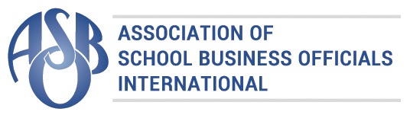
This Meritorious Budget Award is presented to

Greenville
Independent School District

For excellence in the preparation and issuance of its school entity’s budget
for the Fiscal Year 2014-2015.
The budget adheres to the principles and standards
of ASBO International’s Meritorious Budget Award criteria.
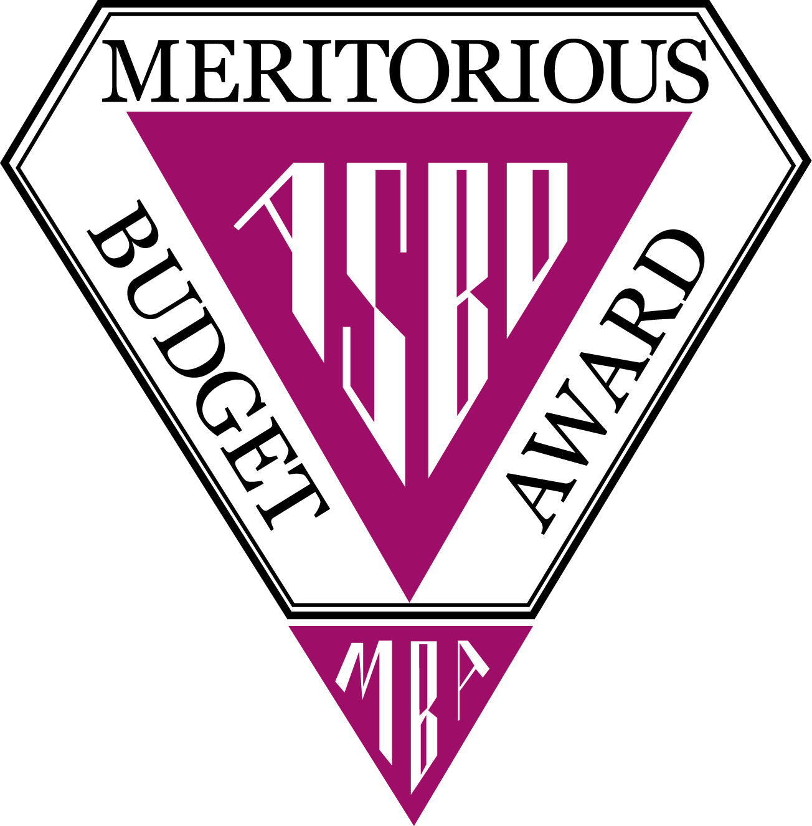
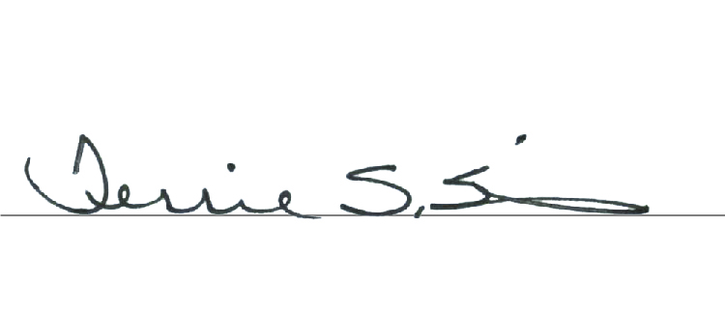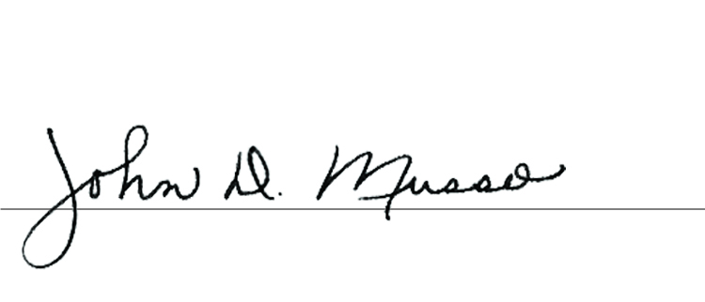
Terrie S. Simmons, RSBA, CSBO John D. Musso, CAE, RSBA
President Executive Director

